BIG Torino 2002
International Biennial of Young Art

Turin, April 19 – May 19, 2002

Big Social Game

1__general data
2__general data
3__the theme
4__map Turin

1 general data BIG Torino 2002

artistic director : Michelangelo Pistoletto

artistic committee : Giacinto di Pietrantonio,
Director Galleria Arte Moderna e Contemporanea - Bergamo, Italy
calc,
Laboratorio Cultural, Artists - Spain
Christian Marclay,
Artist, Curator - New York, USA
Corinne Diserens,
Art curator – Marseille, France
Vittorio Castellani,
Gastronomade, enogastronomy journalist - Turin, Italy
Stefano della Casa,
Director Torino Film Festival – Turin, Italy
Aldo Nove,
Writer – Milan, Italy

Organising Board : City of Turin
Province of Turin

Piedmont Region
BIG Torino 2002 is organised by the City of Turin, in collaboration with the Province of Turin and the Region of Piedmont, three local public Administrations, for years active and sensitive to the young people’s artistic productions, that have together elaborated a new cultural project aimed to the promotion of international young creativity. BIG Torino (Biennale Internazionale Giovani) is a multidisciplinary event conceived and designed with the objective to offer opportunities of expression and prominence to the new generation of emerging artists. BIG Torino 2000, the first edition of the International Biennial of Young Art, which took place in Turin last April, has been successfully greeted by both the public and the critics. Indeed, we have welcomed 150.000 visitors, 520 artists, 240 journalists and more than 300 cultural operators from all over Europe, while 42 European Cultural Institutions were involved.

organisation : Luigi Ratclif,
Organising Director
Afrodite Oikonomidou,
International Relations, Hospitality
Patrizia Rosello,
Public Relations
Fulvio Spada,
Administration

theme : BIG Social Game
see page 3

artistic fields : Visual Arts
Cinema
Architecture
Design

Fashion

Music
Performing Arts
Writing
Gastronomy
New Media

2 general data BIG Torino 2002

who : artists under 35 years from all the countries of the european continent

when : 19th of April – 19th of May 2002

where : The artistic event will take place in Turin, in the central historic area of the city in venues and theatres located in the city centre with extensions in some suburban zones (see page 4)

how : BIG international section – exhibitions, shows, concerts, conferences
with the participation of the international guests.

BIG workshops – an art training section dedicated to the guest artists and to the young artists from Piedmont.

BIG bang – decentralisation of activities and events in the Province and the
Region.

BIG schools – an educational project which aims at generating an active
participation of school students of every type and level.

BIG wave – events organised in collaboration with International Cultural
Institutions.

participants : around 300 artists will be invited in all the different art fields coming from Europe and from the guest country.

guest country : big-guest.net - Internet, the “netland”

deadline : proposals must be sent until the 31st of May 2001 to:

BIG Torino 2002
Via Maria Vittoria 18

10123 Torino – Italia

requested material : artistic c.v., brief description of the project, an estimation of the
production cost if necessary, photographic material, short
documentation of the previous works, videos, urls etc.

selection : the artistic committee will select the participating projects within the end
of June 2001. Selected artists and groups will be informed immediately.

contact : for further information please contact :

email : big2002@comune.torino.it
tel. : +39 011 443 00 43 / +39 011 443 00 80
fax. : +39 011 4430048
www.bigtorino.net

3 the theme BIG Torino 2002

BIG Social Game

Preparations for the second edition of Turin’s International Biennial of Young Art – BIG Torino 2002 – are now under way. The Organising Board’s extraordinary zeal is now concentrated on drawing up a programme in which the objectives of this great event will be further defined and outlined following a totally distinct physiognomy from those of other artistic and cultural events held in different parts of the world. By Statute Turin’s Art Biennial is dedicated to young artists between eighteen and thirty-five years old, and by programme choice it is open to all the disciplines in the artistic sphere: visual arts, theatre, music, dance, cinema, architecture, design, fashion, writing and gastronomy.

Having originated during the years that have seen an exponential acceleration of change in the means and systems involving and conditioning the whole of human society, Turin’s Biennial intends to research and present those creative forms that confront the problems of society in today’s complex and contradictory panorama of civilisation.

Consequently, the contemporary presence of various artistic disciplines in a single event will not be presented as a concentration of festivals or separate events, but as territory, both ideal and practical, where the different fields are brought closer together by means of a precise common objective. This objective can be identified in a precise need that is intrinsic to every single artistic expression and in harmony with the widespread, much felt requirements in the vast context of society.

This convergence and coming together of divers expressive forms (while maintaining a maximum degree of autonomy in their differences) is comprised in the significance of a theme that organically links art with social structures. Precisely this connection between art and society is the basic reasoning that will give an organic sense to this Turin Biennial.

I thought, in fact, of connoting this event with a title announcing the programme – BIG Social Game: let us play together at changing society. This is an invitation to young people, to those young people in every artistic field who today feel an urgent need to launch their imagination upon ideas of sensitive, responsible social transformation.

Art stakes itself in this game and actually intervenes in social spheres without losing its roots or autonomy. This is art’s commitment, a responsibility of art that moves through the charming idea of game playing, adventure and marvel. Things change through play. One can win or lose, it does not matter; the important thing is to play. Pleasure in making forms change is translated into pleasure in bringing changes also to the systems that contain the products, whether they are visual, theatrical, musical or architectural.

Art has reached that degree of excellence and sovereignty that I would define with the paradigm of «orthodoxy». As for the great religions, the cathedrals of art grow ever more numerous and imposing and an auto-referential aura of artistic mysticism is being diffused. This event aims to be placed on another side of art itself, the «heterodox» side. This prepares to meet and intertwine with the ordinary things of life; it mixes with everyday facts; it interacts with the scientific, economic and political undertakings of our time without, though, ever losing its own central propositional capacity. It is not about applied art, it is about implicated art.

The Artistic Director

Michelangelo Pistoletto

4 map detail - Turin BIG Torino 2002
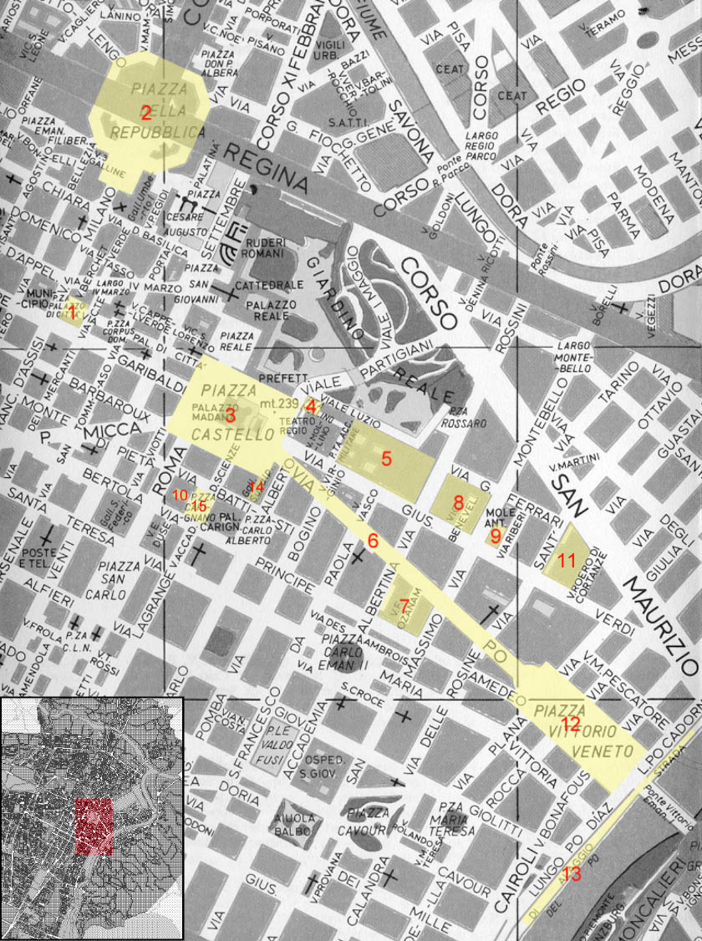
1 - Piazza del Municipio, 2 - Piazza della Repubblica, 3 - Piazza Castello, 4 - Piazzetta Mollino, 5 - Cavallerizza Reale,
6 - Via Po, 7 - Accademia Albertina, 8 - Teatro Gobetti, 9 - Museo del Cinema - Cine Massimo, 10 - Teatro Carignano,
11 - Università – Palazzo Nuovo, 12 - Piazza Vittorio Veneto, 13 - Murazzi del Po, 14 - Galleria Subalpina,
15 - Piazza Carignano

